EMBASSY OF SWITZERLAND IN CHINA

Thierry Courvoisier

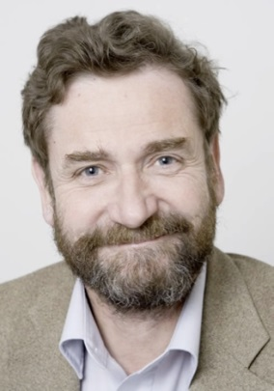
Mr. Thierry Courvoisier is a full Professor at the astronomy department of Geneva University and the director of the ISDC (INTEGRAL Science Data Centre). Raised in Geneva, he got his PHD in astronomy at Zurich University. He worked at multiple pivotal institutions in space research and space policy, such as the ESA (European Space Agency), or the ESOC (European Space Operations Centre). As a researcher, Thierry Courvoisier is the author or co-author of more than 400 scientific publications. His main research is the Active Galactic Nucleus (AGN), but he is also interested in other fields such as high energy astrophysics, observations using satellites and ground based telescopes, or modeling of accretion processes onto black holes and neutron stars.

Since 2013 Thierry Courvoisier also serves as the president of the Swiss Academies of Arts and Science. The Swiss Academies promote the exchange between science and society, unite and connect scientists across institutions and disciplines, and give advice on science-based and societally relevant issues. As president of the Academies, Thierry Courvoisier focuses on sustainable solutions for national and global problems.

Thierry Courvoisier expresses his own opinions through his blog (http://cap.unige.ch/courvoisier/), in which he shares his view not only on astrophysics, but also on various other topics such as energy, climate, genetic engineering or nature. We invite you to visit his blog if you want to get an interesting view on science and its role in society.

Thierry Courvoisier任日内瓦大学天文系教授和ISDC主任。在日内瓦长大的他获得苏黎世大学博士学位。他和诸多航空公司合作过，如瑞士文理科学院、欧洲太空运作中心等。Thierry Courvoisier的作品丰富多彩，他一生参与过400多个科研项目。他的主要研究领域是活动星系核，但也对高能天体物理学、使用人造卫星和基于地面的望远镜的观测、黑洞和中子星的吸积模型感兴趣。

从2013年起，Thierry Courvoisier当选瑞士文理学院主席，该学院致力于促进科学与社会的交流、加强各学院学科科学家之间的联系，并为科学和社会问题提供建议。作为学院主席，Thierry Courvoisier的主要任务是研究解决国内和国际问题的可持续性方案。

Thierry Courvoisier在他的博客(http://cap.unige.ch/courvoisier/)分享他的观点，不仅包括天文学，同时包括基因学、气候、基因工程或自然界等话题。如果你对科学及其在社会中扮演的角色感兴趣，请关注他的博客。

